Write a C program to simulate:
a) Producer-Consumer problem using semaphores.

#include <stdio.h>
#include <stdlib.h>
int mutex = 1;
int full = 0;
int empty = 3, x = 0;
void wait_sem(int *s)
{
(*s)--;
}
void signal_sem(int *s)
{
(*s)++;
}
void producer()
{
if ((mutex == 1) && (empty != 0))
{
wait_sem(&mutex);
full++;
empty--;
x++;
printf("Producer has produced: Item %d\n", x);
signal_sem(&mutex);
}
else
{
printf("Buffer is full!\n");
}
}
void consumer()
{
if ((mutex == 1) && (full != 0))
{
wait_sem(&mutex);
full--;
empty++;
printf("Consumer has consumed: Item %d\n", x);
x--;
signal_sem(&mutex);
}
else
{
printf("Buffer is empty!\n");
}
}
int main()
{
int choice;
while (1)
{
printf("\n1. Producer");
printf("\n2. Consumer");
printf("\n3. Exit");
printf("\nEnter your choice: ");
scanf("%d", &choice);
switch (choice)
{
case 1:
producer();
break;
case 2:
consumer();
break;
case 3:
exit(0);
default:
printf("Invalid choice!\n");
}
}
return 0;
}

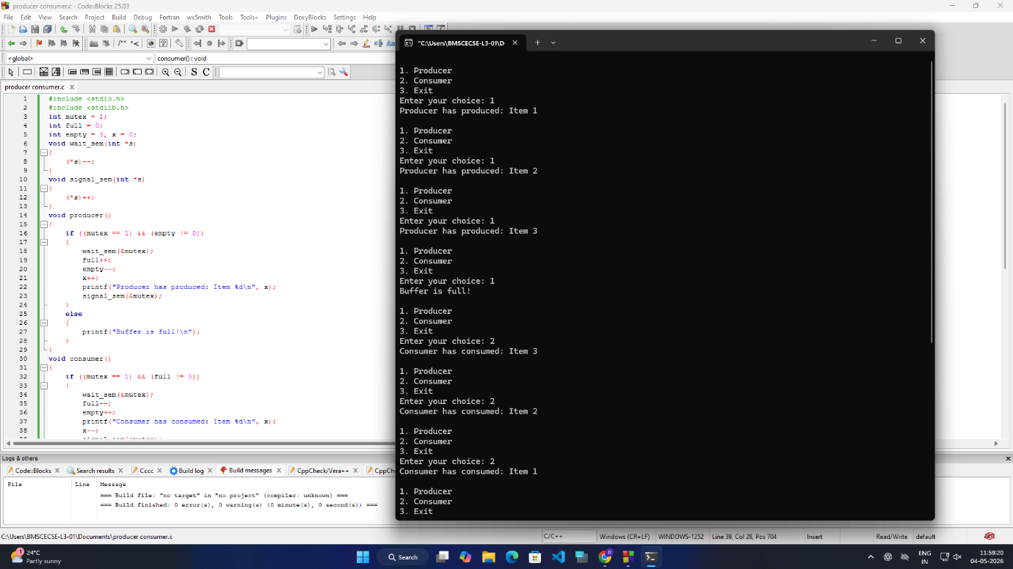

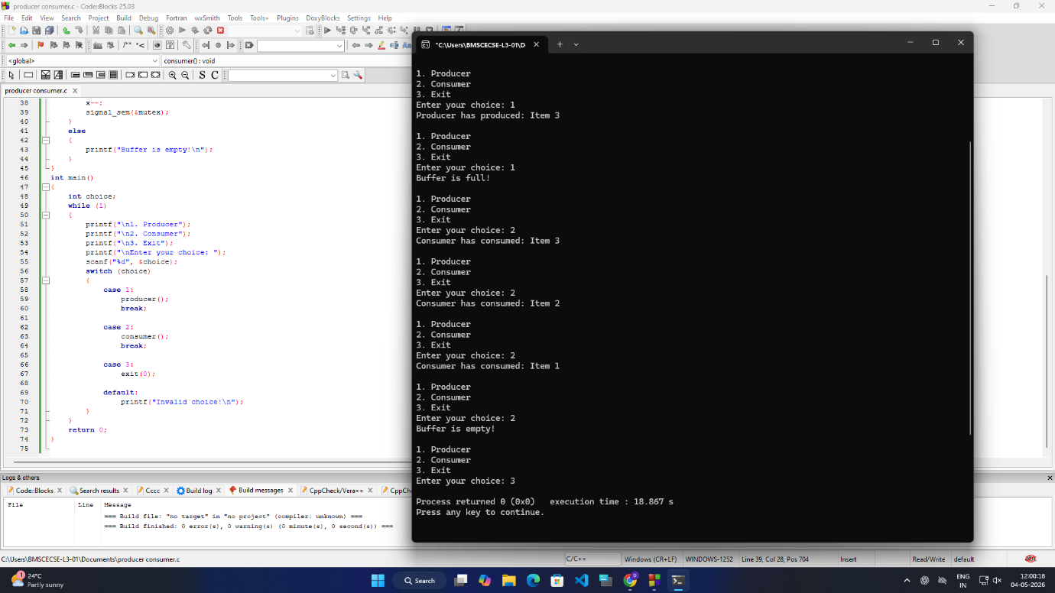

b) Dining-Philosopher’s problem

#include <stdio.h>
int main() {
int n, hungry, pos[10];
int choice, i, j;
printf("Enter the total number of philosophers: ");
scanf("%d", &n);
printf("How many are hungry: ");
scanf("%d", &hungry);
for (i = 0; i < hungry; i++) {
printf("Enter philosopher %d position (1 to %d): ", i + 1, n);
scanf("%d", &pos[i]);
}
while (1) {
printf("\n1. One can eat at a time\n");
printf("2. Two can eat at a time\n");
printf("3. Exit\n");
printf("Enter your choice: ");
scanf("%d", &choice);
if (choice == 3)
break;
if (choice == 1) {
printf("Allow one philosopher to eat at any time\n");
for (i = 0; i < hungry; i++) {
for (j = i; j < hungry; j++) {
printf("P %d is waiting\n", pos[j]);
}
printf("P %d is granted to eat\n", pos[i]);
printf("P %d has finished eating\n", pos[i]);
}
}
else if (choice == 2) {
printf("Allow two philosophers to eat at any time\n");
for (i = 0; i < hungry; i += 2) {
for (j = i; j < hungry; j++) {
printf("P %d is waiting\n", pos[j]);
}
printf("P %d is granted to eat\n", pos[i]);
printf("P %d has finished eating\n", pos[i]);
if (i + 1 < hungry) {
printf("P %d is granted to eat\n", pos[i + 1]);
printf("P %d has finished eating\n", pos[i + 1]);
}
}
}
else {
printf("Invalid choice\n");
}
}
return 0;
}

